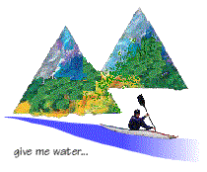 | Copeland Canoe Club | 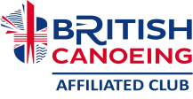
15th Ravenglass Seaquest 11th September 2022

Having carefully considered our options following the death of Queen Elizabeth ll we decided to run the event preceded by a minute's silence which was respectfully observed by all.
The weather forecast had varied so much during the week so we were pleased to greet our competitors on a fine day with light winds which were due to strengthen slightly throughout the day.

From as early as 8 a.m. boats began to arrive. With a high spring tide of 8.3m, and HW at 1251, competitors with a good variety of craft drove down onto the beach helping to create an increasingly excited atmosphere as the time for the compulsory safety briefing approached.
Competitors from all levels of the paddling world registered, from elite racers, through teams of regular paddling friends to families with young children. The wide gamut of entrants informs us that we are succeeding in our aim to be inclusive to all.

This is the first year we've needed to shorten the Irt section due to cows with calves so more controls were placed on the Esk. I received no negative feedback on this decision.

A full list of results can be found on the CCC website, www.copelandcanoe.org.uk. See the Seaquest page.

Having verified everyone's safe return, including our race stewards, our prize presentation took place, as usual, in the garden of the Ratty Arms. It was lovely to be able to present so many prizes to the younger paddlers as well as the adult competitors who all put so much effort into their achievements.
This year we have so far raised roughly £200 divided between the CCC defibrillator fund and Children of Ukraine. This is usually increased by Sellafield Group who donate £100, and we're hoping to further increase this via our connections with Outdoor Partnerships Cumbria.
Many thanks to prize donors Rivers Publishing and Outdoor Partnership Cumbria, to all the paddlers who participated, and to Team Copeland who oversaw the logistics, administration and safety at the event

Team Copeland for Seaquest this year were:
Andrew Bennion; Colin Braithwaite ; Karen Braithwaite ; Mark Jones; Pete Nelson; Laura and Daniel Atkinson; Joe Stalker; Dave Topliss; Alastair Yates; Roger Blake, and Jenson Skillen

