 |  | 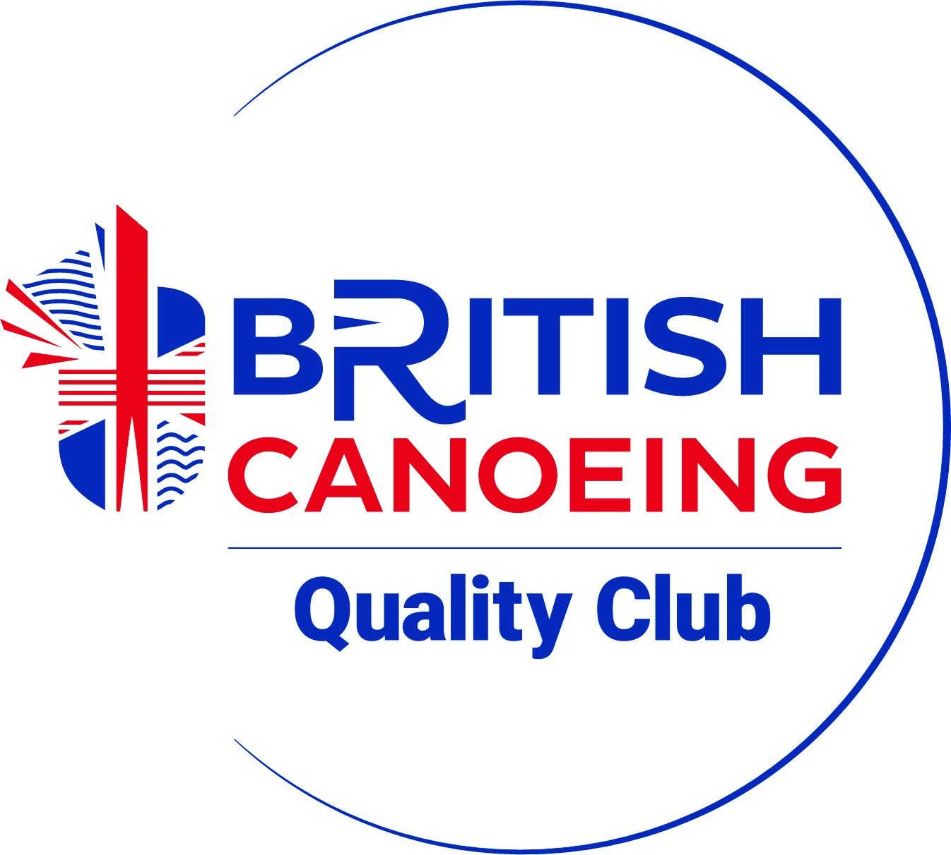

Report for 16th Ravenglass Seaquest
21st May 2023

Back to May for this year's event, we were pleased to see that the weather forecast was for a warm and dry weekend with a light breeze, this was perfect for the wide range of self propelled craft which participate.
As usual, most entries were taken on the day, so the registration office was kept very busy by the 64 competitors entering right up until the time to get all the cars moved from the quickly rising tide.
We welcomed paddlers of all ages and abilities with a fabulous array of craft, ranging from family groups with young children in general purpose boats, inflatable kayaks, SUP's, open canoes, sea kayaks, and racing kayaks. This is an event that everyone can tackle in their own way.
Paddlers need to decide on the best strategy to obtain as many points as possible taking into account the tide and winds. With HW being 7.7m this year, it wasn't a massive spring tide so navigation to the top of the narrower estuaries could prove challenging too.
Given the conditions it wasn't surprising that most competitors used the whole 3 hours allowed before returning to base, to check in.
Within the hour, the results had been collated and we met up at The Ratty Arms for prize presentation. The new manager of the pub kindly donated to the charity and we wish her every success in her new venture at the newly refurbished pub and gardens.
We had 17 categories, several of which were hotly contested with elite paddlers running to the check-in having chased each other right to the last moments of the race.
We had quite a few prizes to award, so it was heart-warming so see that everyone stayed on in the beer garden to congratulate every last winner.

All results can be found on the CCC website:

https://www.copelandcanoe.org.uk

Our Charity this year:
We always raise funds for local charities with which we have some involvement, and this year the nominated charity was Cystic Fibrosis. Steve Walter, a club member who lives with this condition, is undertaking a self funded, sponsored paddleboard journey out in the Bermuda Triangle to raise funds so we decided to donate the £400 from Seaquest to this well deserving research charity. You can find out more about his journey here :
www.gofundme.com/f/crossing-4-cf

Thanks to everyone for coming to participate in the event, and to Team Copeland who planned oversaw, provided safety cover, produced maps, and generally did an A1 job.
Team Copeland this year were :
Pete Nelson, Alastair Yates, Joe Stalker, Dave Topliss, Andrew Bennion, Mark Jones, Bob Frazer, Phil Cheek, Laura Pattinson, Daniel Pattinson, Karen and Colin Braithwaite

Hope to see you all again next year.

