Paddle UK – Copeland Canoe Club

Event Safety Summary for Seaquest 2025

Name of activity: | Ravenglass Seaquest 2025
Description of activity: | Assorted boats event. Suitable for reasonably experienced paddlers (ie roughly Discovery and above...)
Activity date & time: | Sunday 13 July 2025  Registration from 10:00, briefing 11:45, start 12:00, end 15:00
Activity venue: | Ravenglass CA18 1SJ: Esk, Mite, Irt estuaries
Entry arrangements | Enter prior to event or on the day
Boats and kit | Participants please bring own equipment.  CCC can provide some equipment to members by prior arrangement
Route | See map: estuaries of Esk, Mite, Irt
Escape route(s) | Paddlers can egress on bank, footpath on N side of Esk estuary.
Contingency Plans | High winds / other poor weather will lead to reduced event, cancellation or change of date.
Event officials | Organiser – K Hetherington Safety officer – Joe Stalker  Welfare officer – Joe Stalker  First Aid – Kit at registration vehicle, all Coaches on site.
Facilities | Public Toilets are available, at National Park pay/ display car park in the village; postcode CA18 1SJ. Pubs / cafes in the village.

Risk control summary (see risk assessment for full details)
Compulsory to attend event briefing:
Do not get on the water before organiser / safety officer have consulted to ensure safety is in place, When finished, participants / safety team must report back to control.
Suitable personal PFD – Helmet (optional) – Suitable clothing and footwear must be worn. Boat buoyancy must be used. Map for the course in waterproof bag. Checklist for participants.
If you capsize, stay with boat and await rescue or swim boat to shore if near-by. If you are trained in rescue you may do so. It is incumbent upon competitors to help others in trouble. | 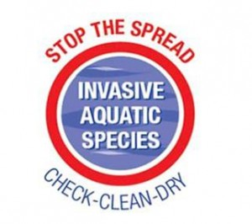
Cover cuts / wash hands before eating - alcohol gel at event control.

If you bring a boat from another catchment area, ensure it is washed / dried out before and after the event to avoid transfer of invasive species.

Emergency response information :
Emergency - Contact details | Karen Hetherington (prior to event) 07721 039 596  VHF: Channel 16. Mobile at event 07721 039 596 or 07711 636 003  At event use 999 / 112 if needs must.
Emergency - Location Details | Give 999 /112 operator – Ravenglass, end of Main Street! Try CA18 1SJ for a postcode as the 999 ambulance system uses postcodes...  Grid ref. SD 084 962
Medical Services Contact Details | West Cumberland Hospital CA28 8JG  01946 693 181

